Creating Z-Inspector Profiles for Strata and Apartments
Objective
This SOP outlines the steps to create and customize Z-Inspector profiles for strata properties to ensure accurate and efficient documentation.
Key Steps

1. Create a New Profile 0:00
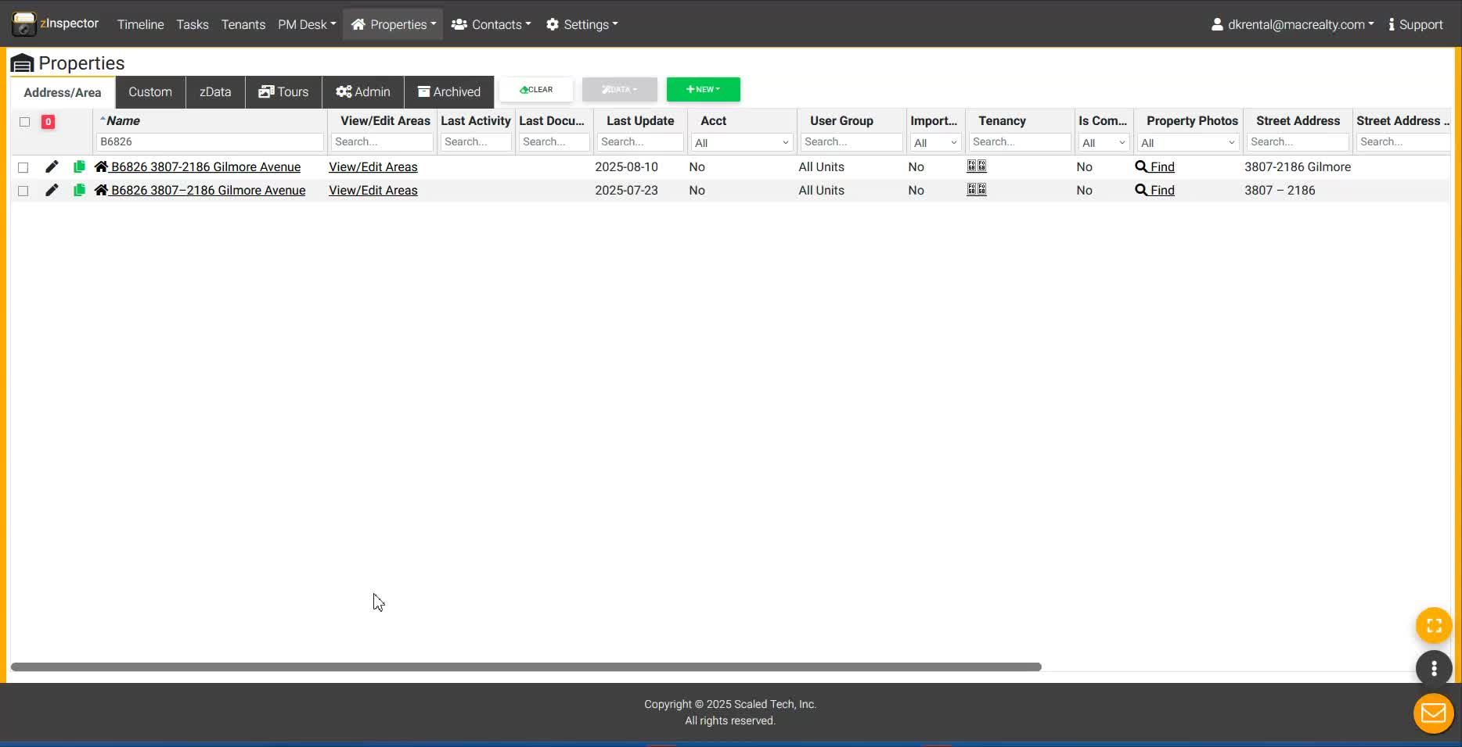
- Log into Z-Inspector.
- Search for existing profiles using the property number.
- If no profile exists, create a new one.

2. Customize Property Features 0:18
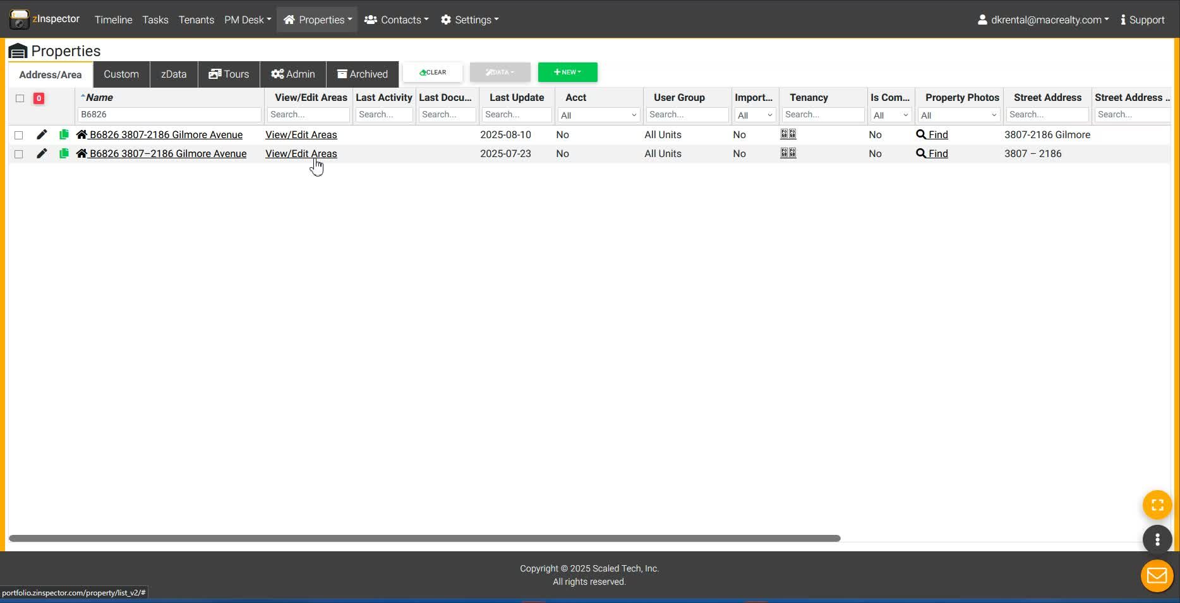
- Identify the type of property (e.g., strata, apartment).
- Remove irrelevant features (e.g., front yard for apartments).
- Customize the flow of the profile based on the property's layout.

3. Document Room Types 1:14
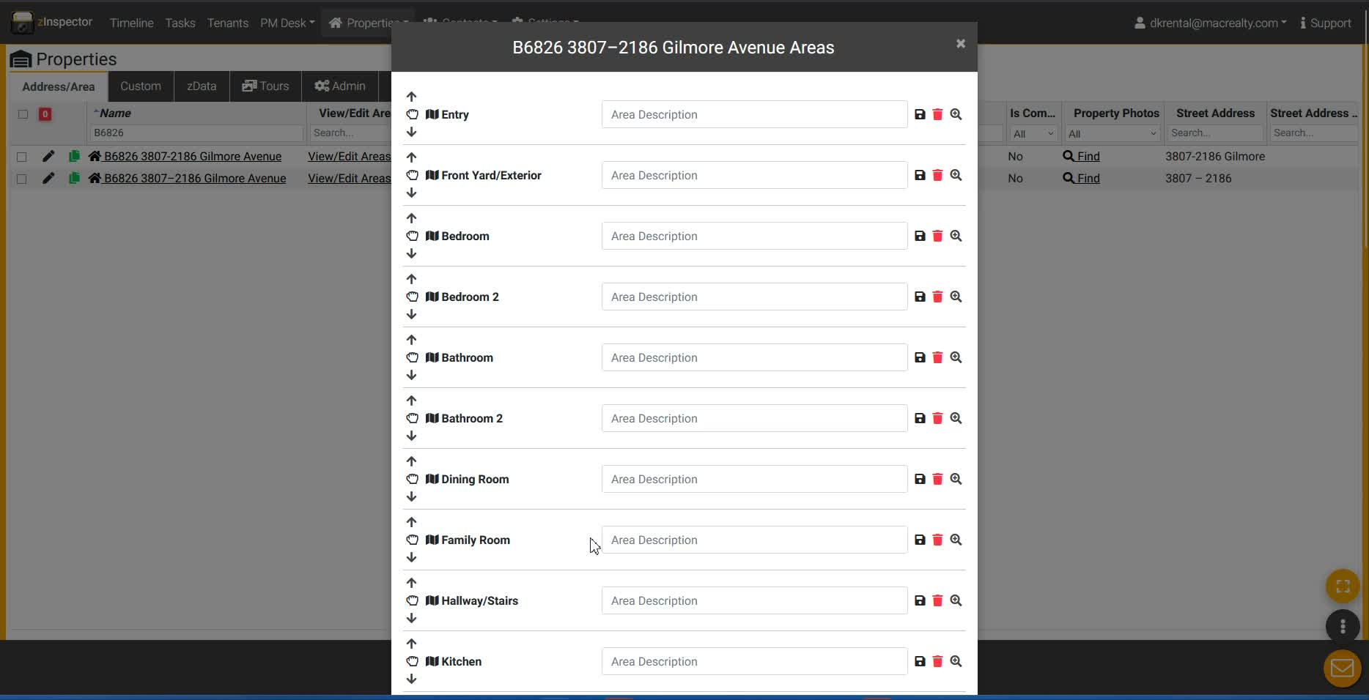
- Confirm the number of bedrooms and bathrooms.
- Include relevant rooms (e.g., kitchen, living room).
- Delete unnecessary room types (e.g., family room in condos).

4. Include Safety and Security Features 3:54
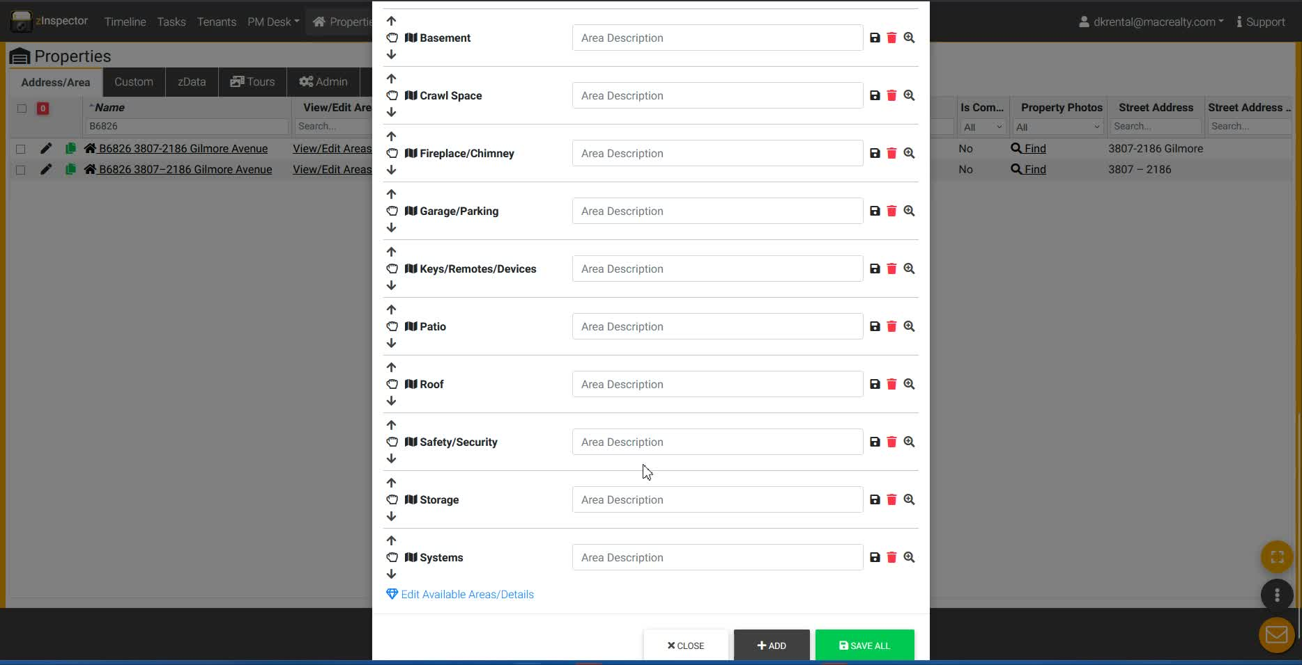
- Document safety features such as smoke detectors and fire alarms.
- Ensure all relevant safety features are included in the profile.

5. Verify Storage and Parking Information 6:43
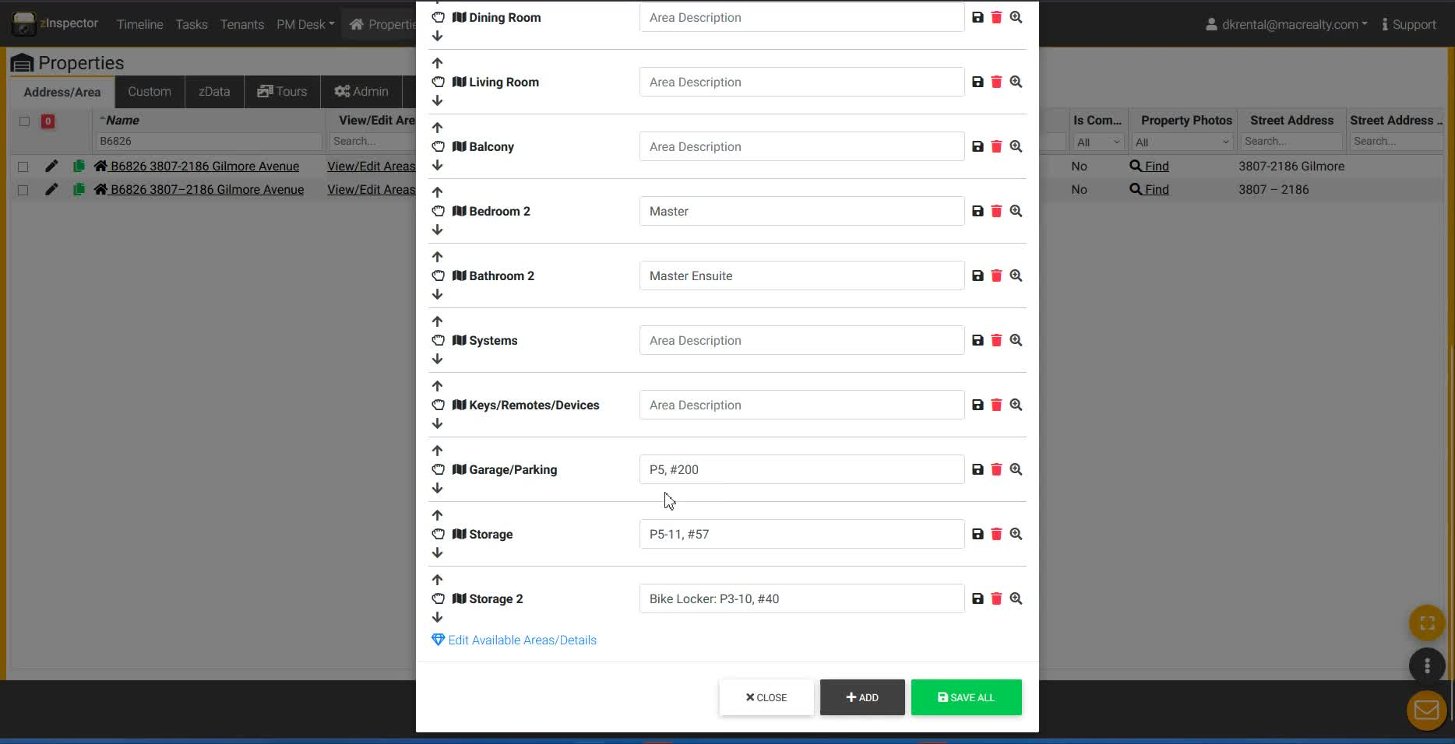
- Document storage options (e.g., storage lockers, bike storage).
- Include parking stall information if applicable.

6. Conduct a Walkthrough 8:05
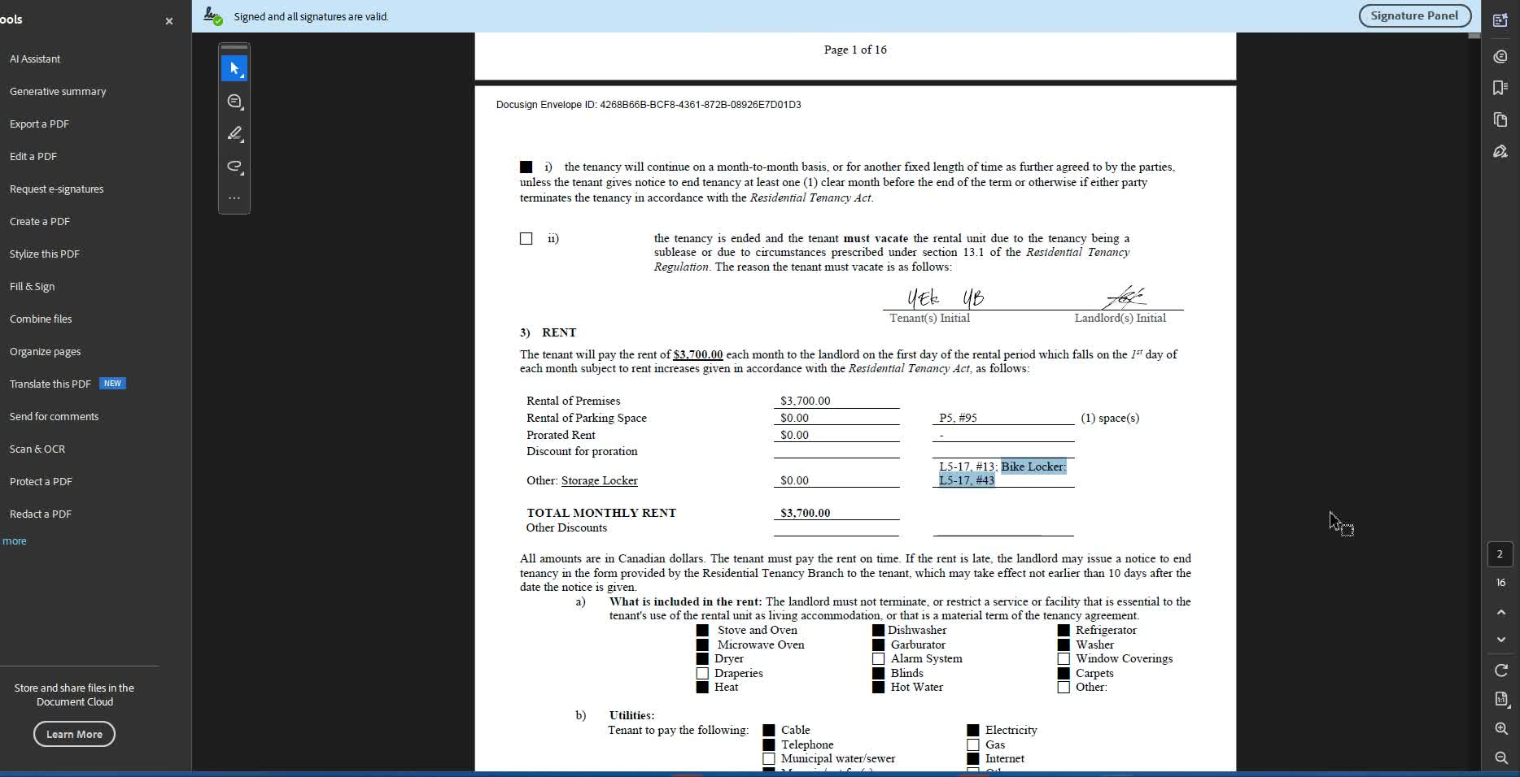
- Perform a walkthrough of the property to verify all details.
- Ensure all features are accurately documented in the profile.

7. Update Tenant Information 9:10
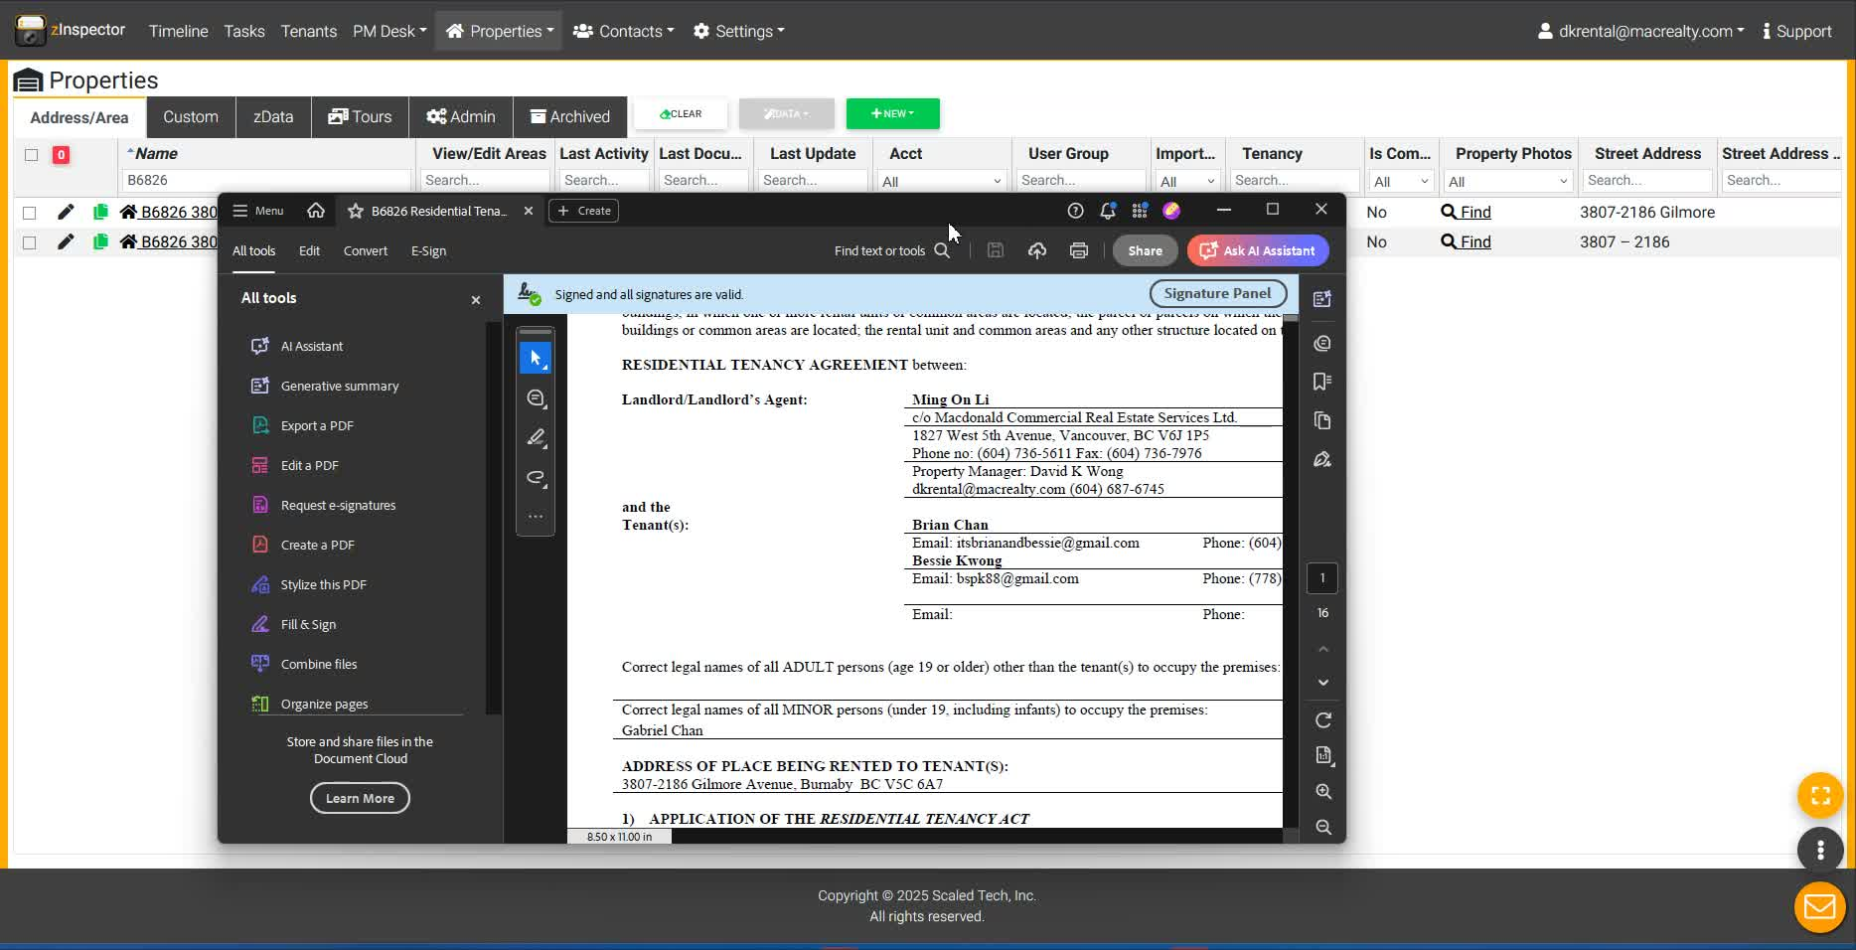
- Input tenant contact information into the Z-Inspector profile.
- Ensure the tenant is correctly assigned to the property.

8. Attach Lease Agreement 9:23
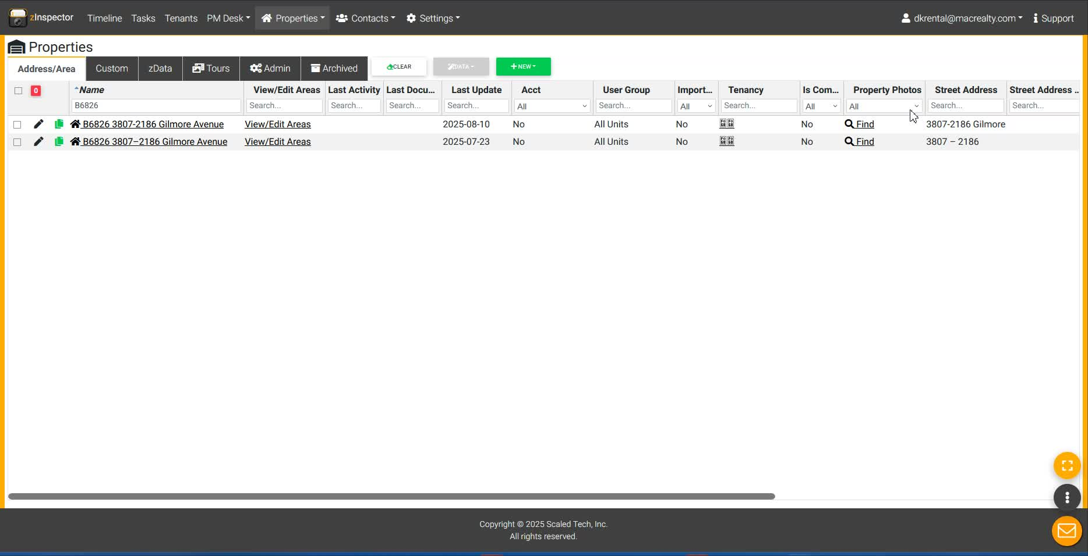
- Attach the lease agreement to the property profile.
- Ensure all tenant details are correctly filled out for efficiency.
Cautionary Notes
- Always double-check the property type to avoid including irrelevant features.
- Ensure that all safety features are documented to comply with regulations.
Tips for Efficiency
- Familiarize yourself with the property layout before creating the profile.
- Use templates for common property types to save time.
- Regularly update profiles with any changes to property features or tenant information.
Link to Loom
https://loom.com/share/4af997e6f76a4e599dd0f93da4588aa2

Creating and Customizing Z-Inspector Profiles for Strata Properties

1. Introduction to Z-Inspector Profiles 0:00

- Overview of the purpose of the Loom video.
- Explanation of the need for creating customized profiles for strata or apartment-type buildings.

2. Importance of Customization 0:18

- Standard templates may not fit the unique features of strata properties.
- Need to customize the flow and content of profiles to avoid confusion.

3. Key Features of Strata Properties 0:36
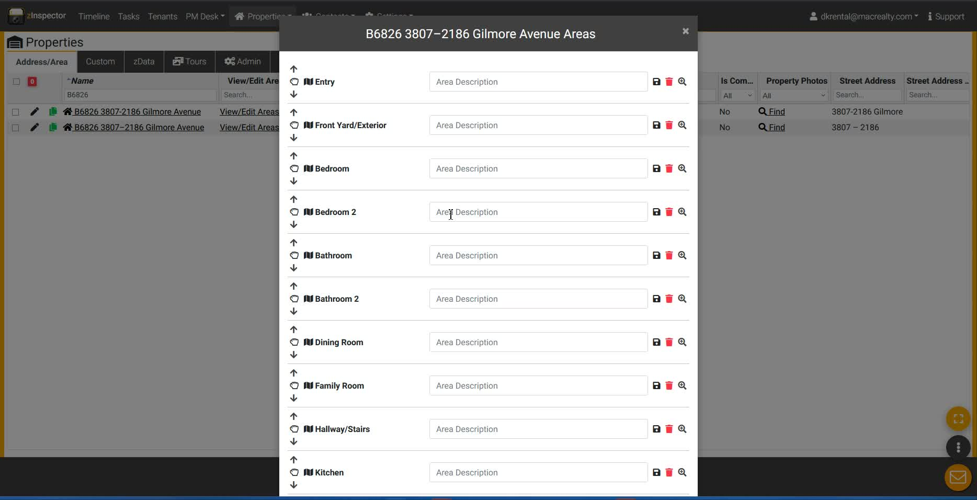
- Discuss differences between strata and single-family homes:
  - No front yard for apartments.
  - Variability in features like balconies, patios, and flex rooms.

4. Navigating the Profile Template 1:14

- Importance of understanding the layout and features of the property.
- Examples of common rooms and their relevance in strata properties:
  - Bedrooms, bathrooms, kitchens, and living areas.

5. Identifying and Removing Irrelevant Features 2:30
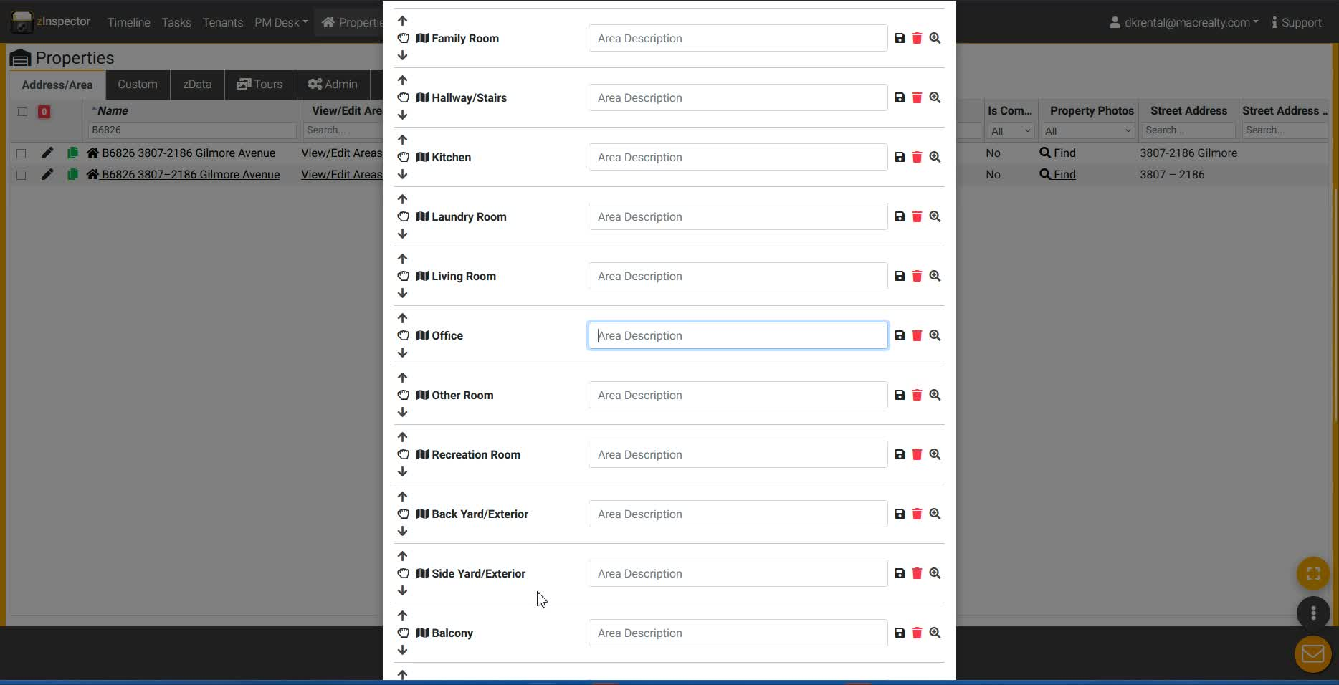
- Clarification on features that do not apply to strata properties:
  - No backyard, side yard, or recreation rooms.
  - Importance of knowing what features to include or exclude.

6. Documenting Property Details 3:12
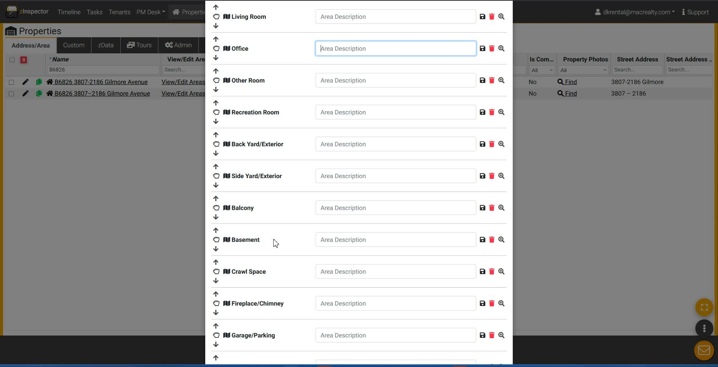
- Importance of documenting safety and security features:
  - Smoke detectors, fire alarms, and security systems.

7. Creating a Flow for Property Walkthroughs 4:38
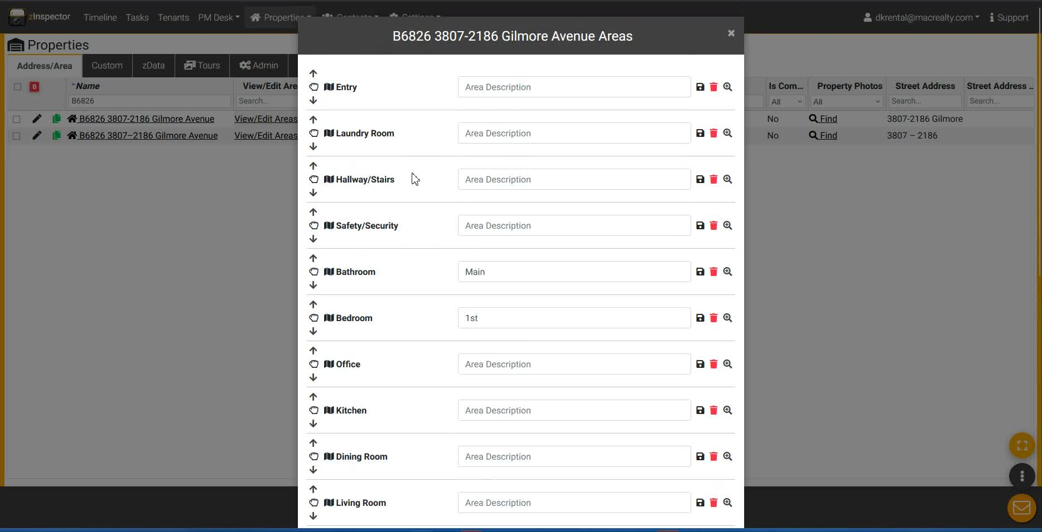
- Step-by-step walkthrough of the property layout:
  - Entry points, room placements, and flow of the inspection.

8. Finalizing the Profile 7:37
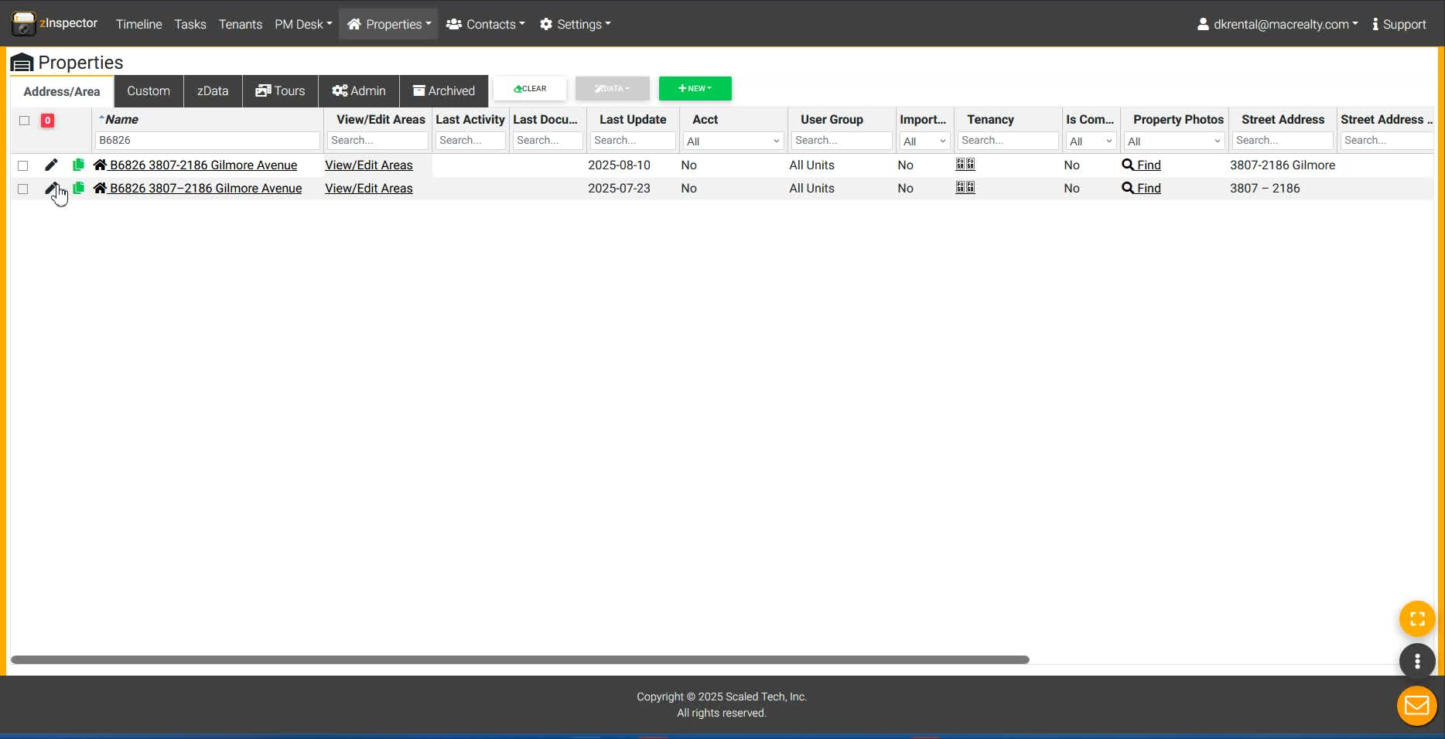
- Importance of reviewing and finalizing the profile before use.
- Removing unnecessary profiles and ensuring accuracy.

9. Tenant Information Management 9:10

- Adding tenant contact information to the profile for efficiency.
- Importance of linking tenants to the correct property and lease.

10. Conclusion and Efficiency Tips 9:44
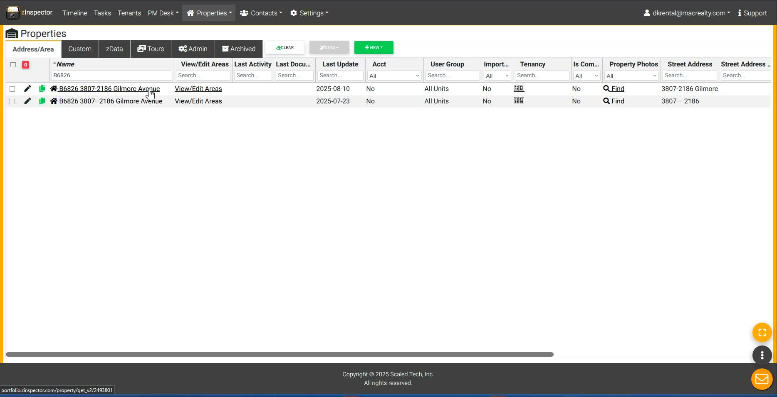
- Emphasizing the benefits of having a well-organized profile for property management.
- Encouragement to learn and adapt the process for better efficiency.
Link to Loom
https://loom.com/share/4af997e6f76a4e599dd0f93da4588aa2

Steps to Reproduce Z-Inspector Profiles

1. Create a New Profile 0:00

- Open Z-Inspector app.
- Create a new profile for a property (e.g., a strata or apartment type building).

2. Customize Property Profile 0:18

- Ensure the profile reflects the unique features of strata buildings:
  - Remove irrelevant fields (e.g., front yard, backyard, recreation room).
  - Add relevant fields (e.g., balcony, storage locker).

3. Verify Room Types 1:49
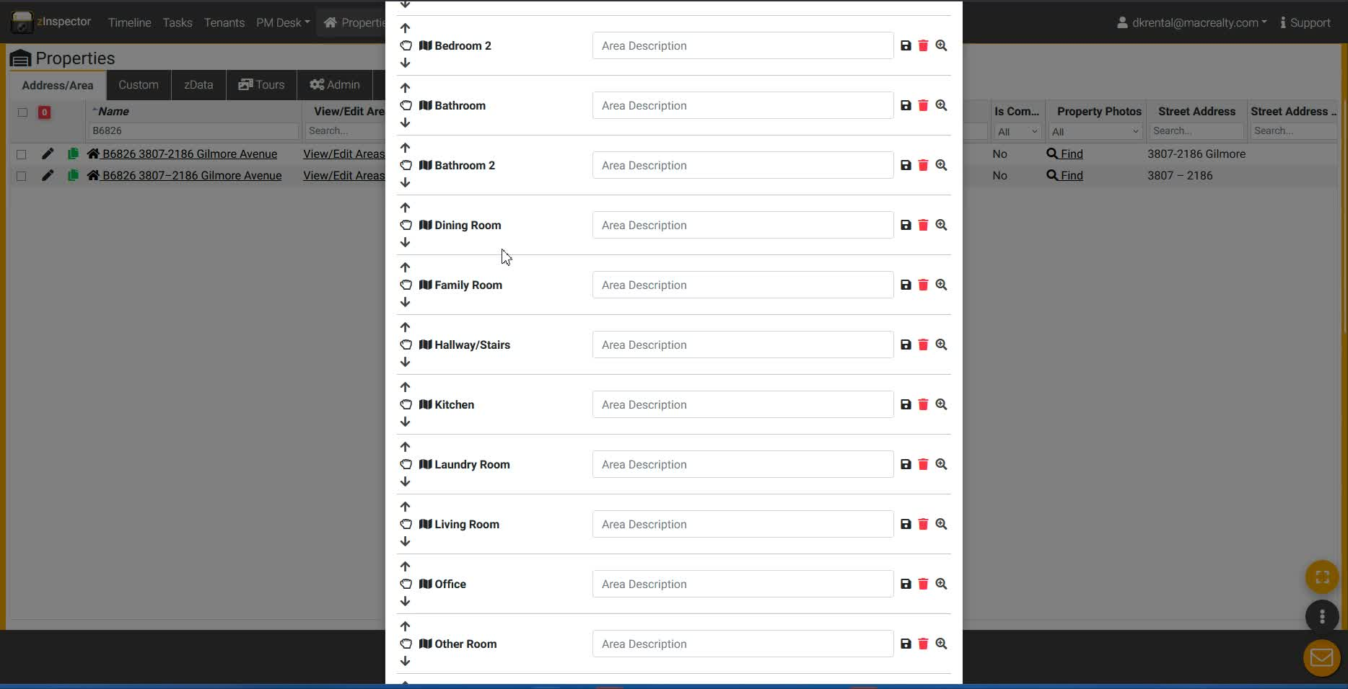
- Check the room types included in the profile:
  - Ensure correct identification of bedrooms, bathrooms, kitchen, etc.
  - Remove any unnecessary room types (e.g., family room, recreation room).

4. Document Property Flow 4:38

- Walk through the property and document the flow:
  - Start from the front entrance and note the sequence of rooms (e.g., hallway, laundry room, bathroom).
  - Ensure safety features (e.g., smoke detectors) are noted in appropriate locations.

5. Check Storage Information 6:55
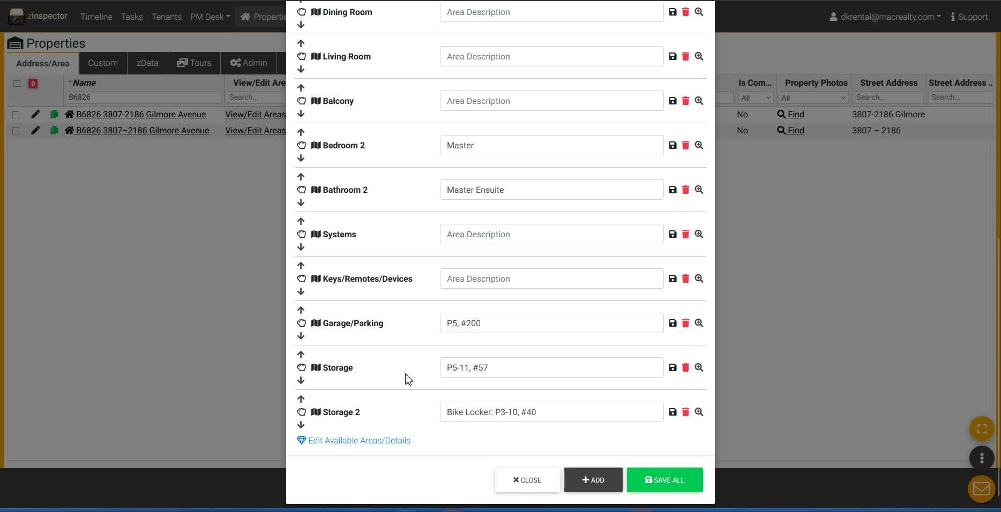
- Verify storage locker details:
  - Ensure correct door numbers and locations are documented.
  - Note any discrepancies (e.g., wrong door number).

6. Update Tenant Information 9:10

- Input tenant contact information into the profile:
  - Ensure it is linked to the correct property.
  - Attach the leasing form for efficiency.
Link to Loom
https://loom.com/share/4af997e6f76a4e599dd0f93da4588aa2

